George Morales
Professor Kristin Williams
CS 385
2 April 2025

Comparing Traditional Text Entry Methods to the Swipe Keyboard
While QWERTY remains the dominant standard for text input, alternative methods such as swipe-based keyboards offer certain advantages in terms of fluidity and simplicity. Swipe keyboards, seen on plenty of mobile devices, allow users to glide across letters to form words, reducing discrete tapping and enabling continuous input.
In my study, I developed a custom on-screen swipe keyboard optimized for desktop use. Instead of traditional clicks, the interface relies on a trail-based cursor system that selects keys through short, intentional hovers. This approach offers an alternative text entry method particularly well-suited for stylus or mouse-driven interaction, as well as accessibility-focused scenarios. To address the challenge of correcting input, I implemented a right-click gesture to delete the last character. Additionally, a space is automatically inserted after each completed swipe to streamline multi-word input. To help level the learning curve compared to the familiar QWERTY keyboard, each participant was given 5 minutes in a dedicated training area to get acquainted with the swipe keyboard and its features.
To evaluate its performance, I conducted a user study with 6 participants, each completing a series of phrase tasks (15 total) using both the traditional QWERTY keyboard and my custom Swipe-based system. This report compares the two techniques across speed (WPM), accuracy (edit distance), character error rate (edit distance), time taken per phrase and backspace use. I chose to put heavy emphasis on the edit distance due to its simplicity and effectiveness in capturing a wide range of common text entry errors, specifically insertions, deletions, and substitutions, all within a single, interpretable value.

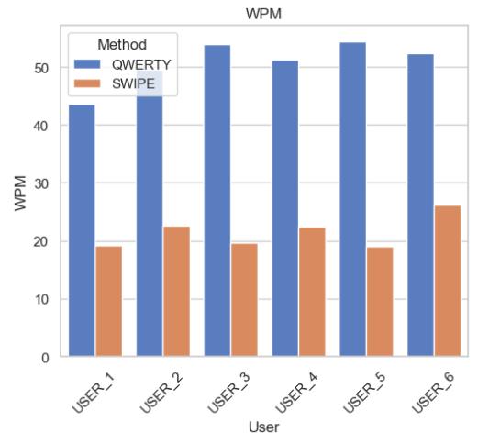
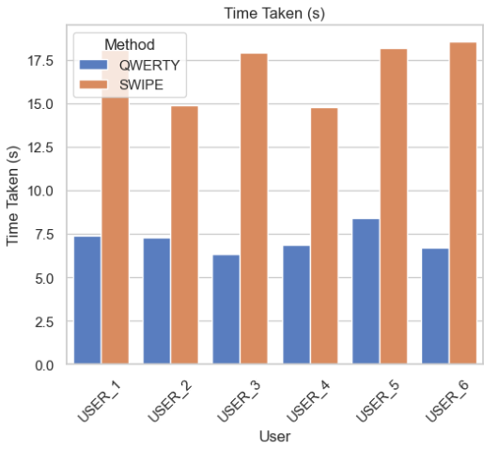
Average [Time Taken / WPM] per User by Input Method Across Both Task Blocks:

Immediately, we can see that the WPM (words per minute) achieved by all users (USER_1 – USER_6) using the traditional QWERTY keyboard consistently outperformed the Swipe Keyboard across the board. QWERTY typing speeds ranged from approximately 43 to 54 WPM, with the highest performer averaging over 54 WPM, while Swipe-based input showed a slower range of 19 to 26 WPM, depending on the user.
Additionally, in terms of time taken, QWERTY users completed their text entry trials in roughly 6 to 8.3 seconds on average, while Swipe users took between 14.7 and 18.5 seconds, more than doubling the entry duration in some cases. This aligns with expectations—while the Swipe Keyboard offers a more accessible or gestural interface, it does so at the cost of speed and efficiency when compared to the familiar and highly optimized QWERTY method.
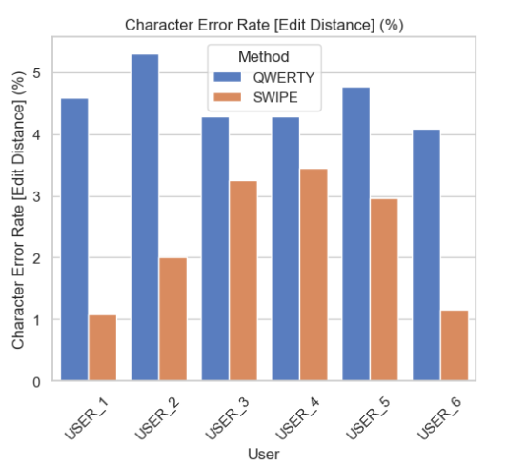
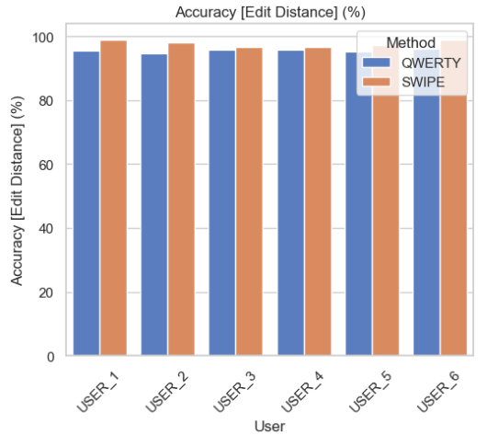
Average [Accuracy / Char Error Rate] per User by Input Method Across Both Task Blocks

However, it seems that this speed up came at the price of accuracy for the QWERYT keyboard, implying that although the Swipe keyboard took twice as long, the character error rate was twice as low. If we look closely, QWERTY entries consistently showed character error rates between 4% and 5.3%, whereas Swipe entries often fell in the 1% to 3.4% range. This suggests that the more deliberate, hover-based input of the Swipe method, while slower, allowed users to make more precise selections—potentially due to the delay buffer, visual feedback, and reduced motor demand compared to fast key presses
In conclusion, while the traditional QWERTY keyboard remains the fastest option for desktop text entry, the Swipe keyboard demonstrated promising accuracy and usability benefits. Despite taking more time per phrase, users made significantly fewer errors using the Swipe system, implicating a more deliberate and controlled input. This tradeoff between speed and precision highlights Swipe keyboards as a strong alternative for users prioritizing accuracy and/or accessibility needs. With further refinement, such as predictive text, my text entry technique could have been even more competitive with the QWERTY keyboard. Ultimately, my study showed that alternative input methods may potentially offer some nuanced advantages beyond raw typing speed.

